Assignment 1

Sachin Shubham

1/29/2021

As a new Data Scientist in the fuel production company you were assigned a task to prepare a slide demonstrating highway gas consumption depending on the type of the vehicle. At the meeting you have decided to use a combination of the boxplot together with the dot plot (as not everyone from the top management knows how to read box plots). You have decided to use mpg data set and your manager showed you the example of expected plot (Figure 1). Using ggplot generate this plot. Using Rmarkdown generate a report containing code, figure (plotted by ggplot) and your personal information (First name, Last name and Student id). You are new at this company but you have heard through the grapevine that your manager is super peaky about anything on the plot, including names of the labels, main title, legend and even italic ”n”.

library(ggplot2)  
e <- ggplot(mpg, aes(class, hwy))  
  
customTitle <- expression(paste("Vehicle type, ", italic("n"), " = 234"))  
  
e + ggtitle("Vehicle type vs Highway miles per gallon") +  
 labs(x=customTitle) + labs(y="Highway miles per gallon") +  
 geom_jitter(aes(color=class)) + geom_boxplot()

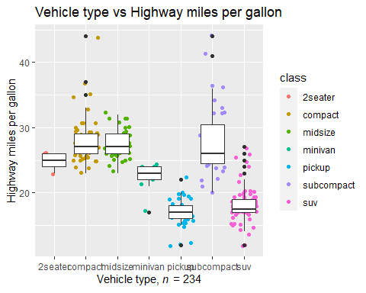

knitr::opts_chunk$set(echo = TRUE)